« Infrastructure / Linux»

Oracle OCFS2/O2CB documentation

Status :

Status | Signification | Explanation
TMP | TeMPorary | Document is in editing state
RDY | ReaDY | Document is elaborated but needs approval.
VAL | VALidated | Document is approved and it is ready to be distributed.

File versioning

Version | Status | Date | Redactor | Modification
1.0 | RDY | 26/12/2018 | Seif KAROUI | Initial creation

Diffusion List

Company / Service | Name | Status  (validator, informed, editor)

Visas & approbations

Company / Service | Name | Date
Content :

1. Context 4
1.1. Document purpose 4
1.2. OCFS2/O2CB definition : 4
1.3. List of servers containing OCFS2 filesystems 5
2. Current cluster configuration 6
2.1. Cluster Version 6
2.2. Configuration files 6
2.2.1. Current ocfs2 configuration file in preprod nodes: 6
2.2.2. Current ocfs2 configuration file in prod nodes: 7
2.2.3. Current o2cb configuration file in preprod nodes: 7
2.2.4. Current o2cb configuration file in prod nodes: 8
3. MCO: 9
3.1. Cluster commands: 9
3.2. Disk extension: 10
3.2.1. Procedure: 10
3.2.2. Known issues: 10
3.3. Troubleshooting : 11

Context

Document purpose
This document is created to give some information on Oracle OCFS2/O2CB installed on Linux infrastructure in CALF.

OCFS2/O2CB definition :
OCFS2 is a general-purpose shared-disk cluster file system for Linux
O2CB is the default cluster stack for the OCFS2 file system.

List of servers containing OCFS2 filesystems

Hôte | IP | IP2 | OS | Heartbeat IP | Role
bck-reai1 | 10.120.3.175 | 10.120.3.177 | RHEL 5.2 | 192.168.1.1 | Node1
bck-reai2 | 10.120.3.176 | 10.120.3.178 | RHEL 5.2 | 192.168.1.2 | Node2
prd-reai1 | 10.120.3.210 | 10.120.3.211 | RHEL 5.2 | 192.168.1.1 | Node1
prd-reai2 | 10.120.3.213 | 10.120.3.214 | RHEL 5.2 | 192.168.1.2 | Node2

Current cluster configuration

Cluster Version
Current OCFS2 cluster version is 1.4.1 :

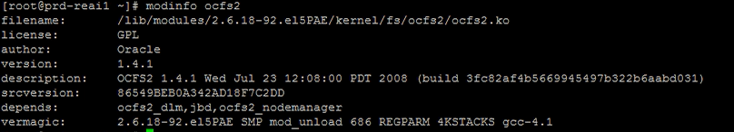

Configuration files
OCFS2 configuration is situated in /etc/ocfs2/cluster.conf
O2CB configuration is situated in /etc/sysconfig/o2cb

Current ocfs2 configuration file in preprod nodes:
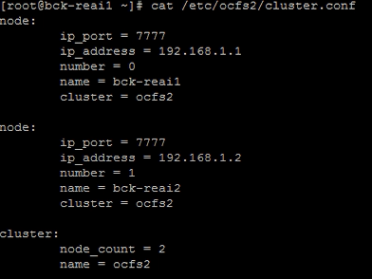

Current ocfs2 configuration file in prod nodes:
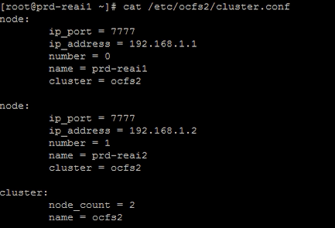

Current o2cb configuration file in preprod nodes:
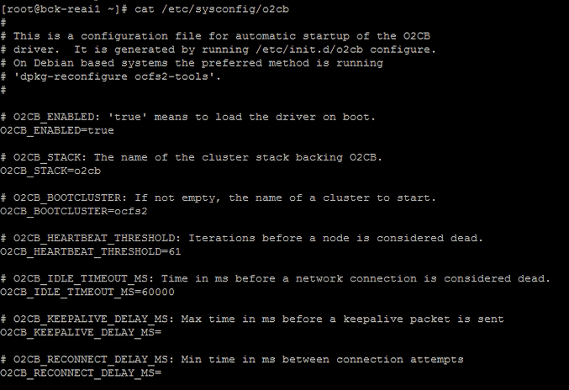

Current o2cb configuration file in prod nodes:

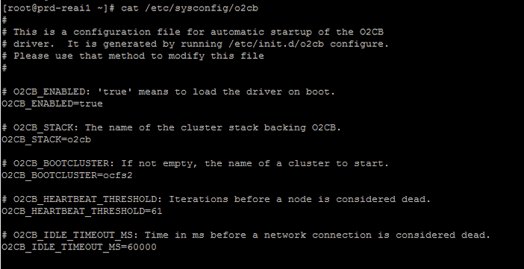

MCO:

Cluster commands:
The init script for o2cb is /etc/init.d/o2cb, available commands includes :
"/etc/init.d/o2cb status"
"/etc/init.d/o2cb start"
"/etc/init.d/o2cb stop"
"/etc/init.d/o2cb load" - Loads all OCFS2 modules.
"/etc/init.d/o2cb online" - Brings the cluster online.
"/etc/init.d/o2cb offline" - Takes the cluster offline.
"/etc/init.d/o2cb unload" - Unloads all OCFS2 modules.

The used tool to check cluster stack health is crstl , the crstl tool is located in /logisys/oracle/product/10.2.0/crs/bin/crsctl

Examples:
Verify CRS (Cluster Ready Service) cluster health:
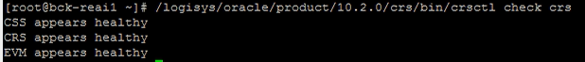
CSS: Cluster Synchronization Services (CSS): Manages the cluster configuration by controlling which nodes are members of the cluster and by notifying member.
Note: a related process is oprocd , failure may result in Oracle CRS restarting the node
CRS: The CRSD manages cluster resources based on the configuration information that is stored in OCR for each resource. This includes start, stop, monitor, and failover operations.
EVM: Event management

Check what votedisk is used:

Disk extension:

Procedure:
The procedure is similar to the extension of EXT2 FS but instead of resize2fs command we use tunefs.ocfs2 -S command , also OCFS2 filesystem resize can only be performed with the filesystem unmounted from all cluster nodes , and also before resizing the device or filesystem, perform a filesystem check ,be sure to correct/address any issues before proceeding.

- Globally unmount partition: # umount /saves
- Perform an FS check # fsck.ocfs2 -fn /dev/savevg/lvsave
- Extend the VG and the LV
# pvcreate /dev/dm-25
# vgextend savevg /dev/dm-25
# lvextend -L +100G /dev/savevg/lvsave
- Extend the FS :
# tunefs.ocfs2 -S /dev/savevg/lvsave
- Perform another FS check before mounting:
# fsck.ocfs2 -fn /dev/savevg/lvsave
- Mount the FS:
# mount /saves

Known issues:
Disk extension of the FS on/dev/savevg/lvsave is not possible in bkp-reai1 and bkp-reai2 because because of some bad blocks , so the disk needs to be formatted before any disk extension.
Error is :
As a temporary workaround another partition /saves_tempo was created to be used as a backup partition of some data.
A symbolic link is created when we need to free some extra space:
[root@bck-reai1 x1eai8]# ll -th CHAUD
lrwxrwxrwx 1 ora1020 oinstall 25 Dec 20 18:10 CHAUD -> /saves_tempo/x1eai8/CHAUD
[root@bck-reai1 x1eai8]# ll -th /saves/x1eai8/CHAUD
lrwxrwxrwx 1 ora1020 oinstall 25 Dec 20 18:10 /saves/x1eai8/CHAUD -> /saves_tempo/x1eai8/CHAUD

Troubleshooting :
- Check the ocfs2 and o2cb services first , a healthy cluster will return the following :
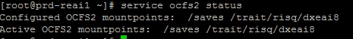
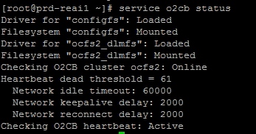
- Check /var/log/messages , if any issue with the network between the nodes you will see current messages
- Check crs stack status with crsctl tool , check section 3.1 .
- Perform fsck to check FS errors if any with the fsck.ocfs2 tool.
- Use debugfs.ocfs2 in case of advanced issue, you need to unmount the partition first .
Example to check locks:
echo "fs_locks" | debugfs.ocfs2 /dev/mapper/savesvg-saveslv
- Useful links:
https://oss.oracle.com/projects/ocfs2-tools/dist/documentation/v1.4/o2cb.html
http://www.oracle.com/us/technologies/linux/ocfs2-best-practices-2133130.pdf
https://oss.oracle.com/projects/ocfs2/dist/documentation/v1.2/ocfs2_faq.html#GENERAL

